Experimental Determination of Absolute Zero

Introduction
Under most conditions of constant pressure, Charles's Law states that the volume of a gas is proportional to the absolute temperature of the gas. Thus, as the average kinetic energy of the gas molecules approaches zero, the volume of the gas also approaches zero. In this experiment a volume of air is cooled and a graph of the temperature and volume relationship is plotted. From an extrapolation of the graph to zero volume, the temperature, in degrees Celsius, at which the average kinetic energy of the air molecules is zero can be predicted. This temperature is absolute zero, or 0 K.

Materials
125 mL Erlenmeyer flask 500 mL beaker or larger solid glass rod
one-hole stopper goggles large bucket
hot plate, pot holders graduated cylinder tongs
ice or snow clamps thermometer

Procedures:
(Goggles required beyond this point!)
1. Prepare an ice bath using a large bucket approximately ¾ full.
2. Fit the dry Erlenmeyer flask with a one-hole stopper.
3. Prepare a hot water bath on the hot plate in a 500 mL beaker.
4. Clamp the Erlenmeyer flask in the hot water bath such that most of the flask is under water.
5. Allow the water to boil 5 min to allow the air inside the flask to reach the temperature of the water bath.
6. Record the temperature of the boiling water to 0.1º C.
7. Place the solid glass rod into the one hole stopper, then remove the Erlenmeyer flask from the beaker.
Allow it to cool for a few minutes, or until it is comfortable to handle.
8. Invert the Erlenmeyer flask and place it in either the ice or room temperature bath. Remove the glass
rod while the flask is inverted under water, then totally submerge the inverted flask for 5-6 min.
9. Record the temperature of the ice bath to 0.1º C just prior to removing the Erlenmeyer flask.

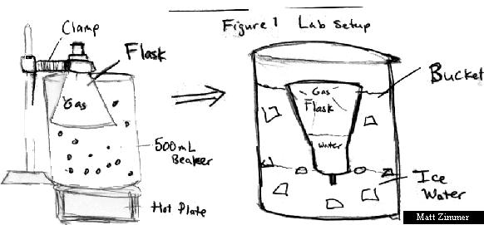

The next step should be done as quickly as possible to avoid warming of the flask.

10. Using your finger tips, raise the inverted flask until the water level inside and outside are equal. Now
seal the inverted flask with the glass rod.
11. Determine the volume of water collected in the inverted flask, by weighing the flask with the water.
12. Measure the total volume of the flask by filling it with water without removing the stopper, then weigh.

Analysis
- Use graph paper to plot the two temperatures and volumes. Extrapolate the line to the y-intercept to determine absolute zero.

1 | 1 | 1 | 1 | 1 | 1 | 1 | 1 | 1 | 1 | 1 | 1 | 1 | 1 | 1 | 1 | 1 | 1 | 1
1
1
1
1
1
1
1
1
1
1
1
1
1
1
1
1
1
1
1

2. Use the equation of a line y=mx+b and solve for “b” to find absolute zero.
- Calculate “m” the slope from (V₁,T₁) , (V₂,T₂).
- Use one of the points to find ‘b”.

3. In your analysis, respond to the following questions:
a) Why did the water flow into the flask in the ice bath?

b) Why was it necessary to allow the two water levels to become equal in Step 10?

- From your graph, what is the predicted temperature for zero volume of a gas, and what does it mean to have zero volume?

- Can a material ever reach absolute zero? Why or why not?

4. How accurate is your result and how could this method be used to get better results?

